Coupled inductors. Spice directive

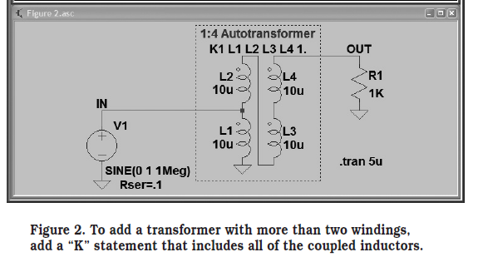K1 L1 L2 1

K2 L1 L3 1

K3 L1 L4 1

K4 L2 L3 1

K5 L2 L4 1

K6 L3 L4 1